AUTHOR PORTFOLIO WEBSITE

**Project Overview**

This guide provides simple steps to create an **Author Portfolio Website** in **Adobe Experience Manager (AEM)** using Out-Of-The-Box (OOTB) components. The website will include the following pages:

* Home
* Books
* About
* Reach Me
* Awards

1. **Setting Up the Base Template:**
2. Open **AEM** and create or use an existing one like myTraining.
3. Set up the required templates and page structures.
4. Ensure the **header and footer** are included at the template level so all pages use them.
5. Use the **OOTB page templates** to create content pages for each section.

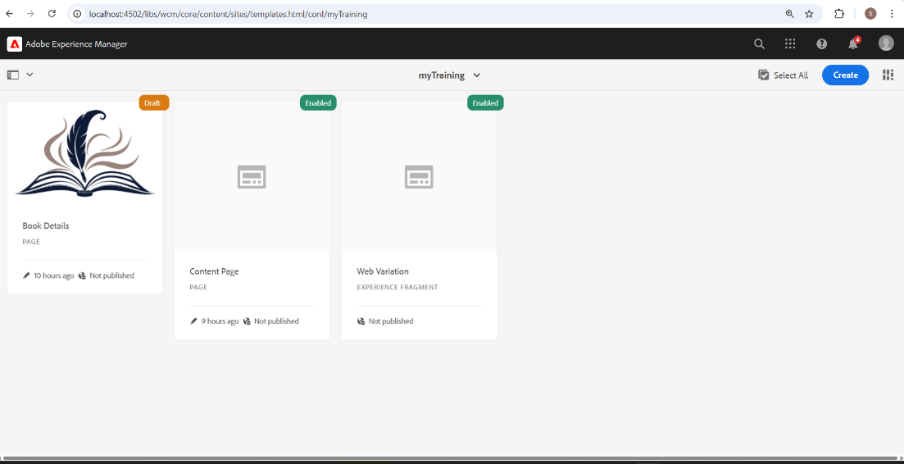

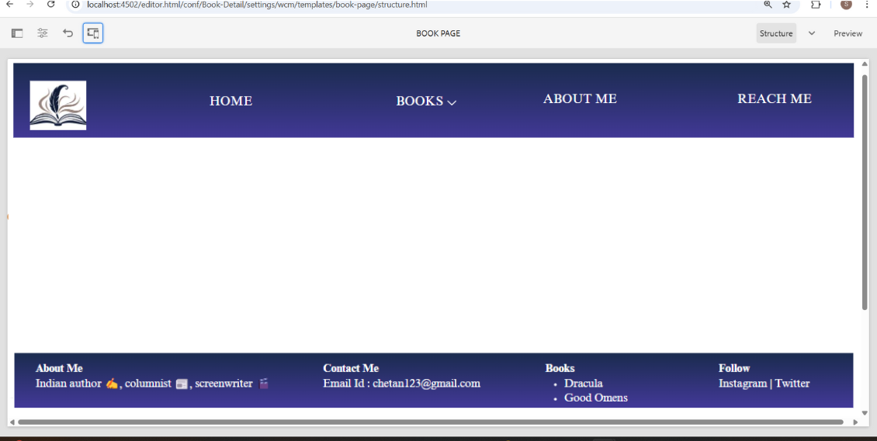

**2. Header & Footer**

**Header:**

* Use the **OOTB Header Component**.
* Add navigation links for **Home, Books, About Me, Contact Me, Awards**.
* Create a dropdown under **Books** to list available books.

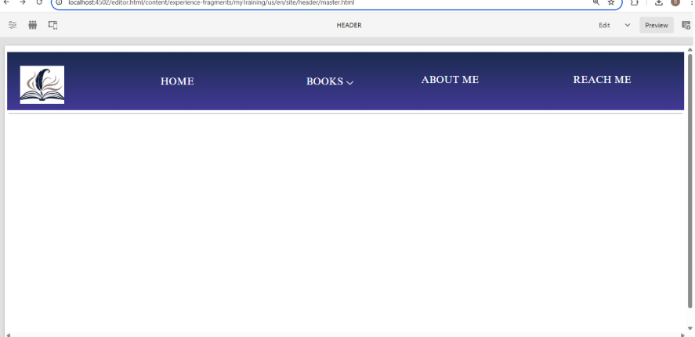

**Footer:**

* Use a **Text or List Component**.
* Include sections: **About Me, Contact, Books (with hyperlinks), Social Media Links**.

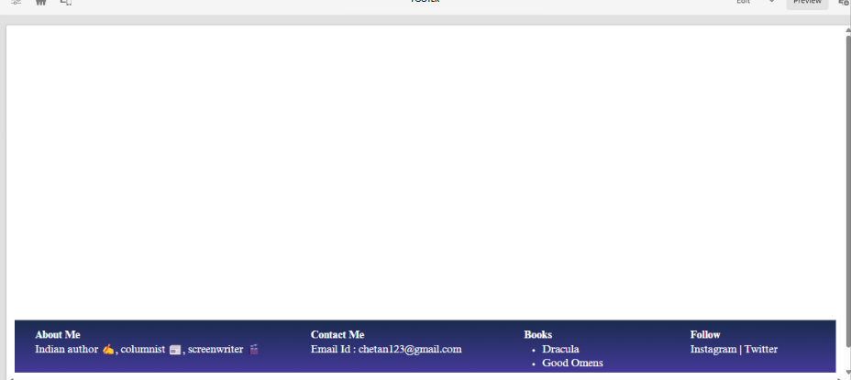

**3. Home Page**

1. Use the **Teaser Component** to display an award ceremony with an image, title, description
2. Add at least **components** like **Text, Image and List**.
3. Include a short introduction about Chetan Bhagat.

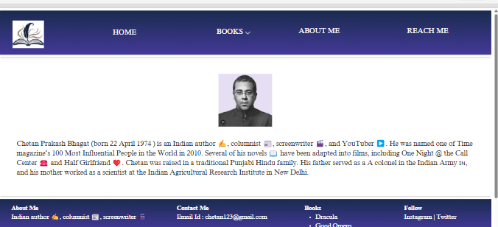

1. **Books Page**
2. Create a **Book Component** that fetches book details from /content/books.
3. Add book pages under /content/books with **Title, Image, and Description**.
4. Ensure each book is displayed as a card with a **unique title, description, and image**.

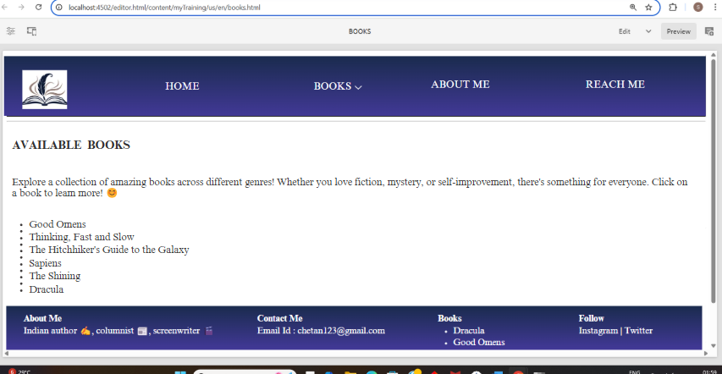

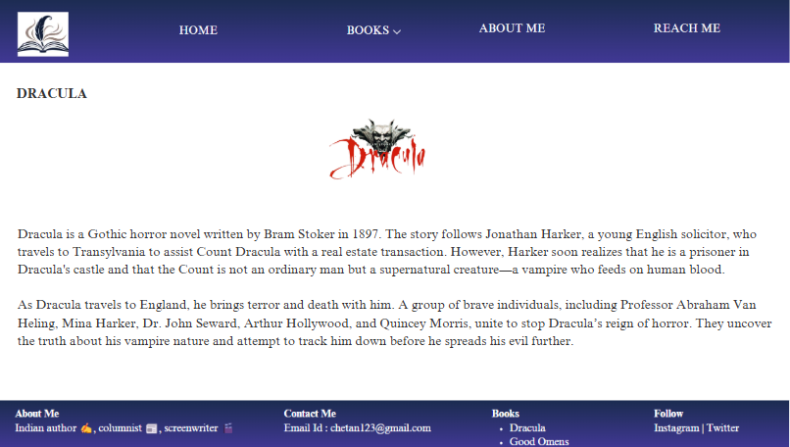

1. **About Me Page**
2. Use the **OOTB Author Component**.
3. Add details about Chetan Bhagat:

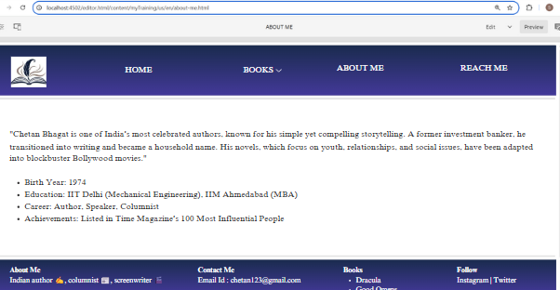

**6. Reach Me Page**

1. Use a **Text Component** to add contact details (email, social media links).
2. Add a **Form** with fields for:
   * Name
   * Email
   * Message
3. Ensure social media icons are properly linked.

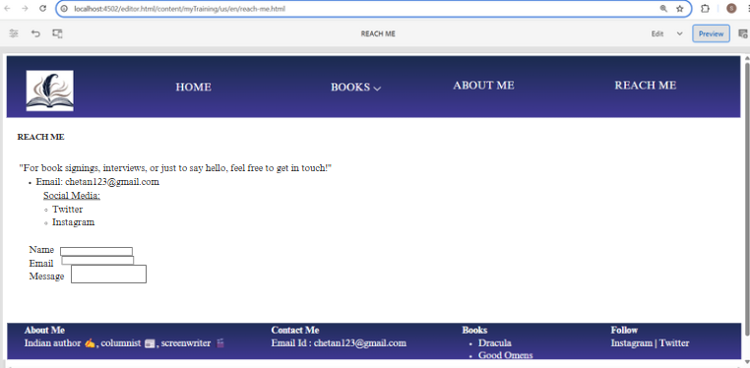

1. **Awards Page**

